Havant Thicket deal: factsheet
Deal Information |  | 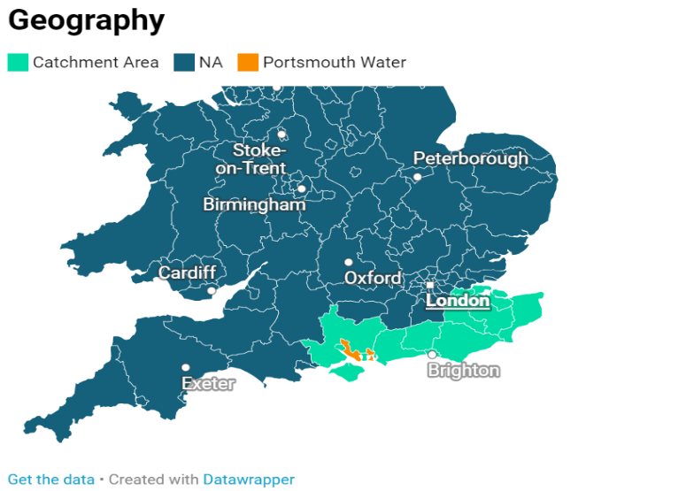  Link to interactive map
Deal signed | 15/03/2023
Project status | Live
Sector | Water
Location | Havant, Hampshire
Counterparty | Portsmouth Water
Total Cost | £339m
UKIB Finance | £50m
Product | Senior Debt

Summary
UK Infrastructure Bank will invest £50m in Portsmouth Water’s Havant Thicket project to build the first reservoir in the UK for 30 years. This project supports both our climate change and local economic growth objectives by boosting the resilience of water supply systems for Southern England and reducing the likelihood of disruptions for local communities. This is a collaborative project between two companies, building a reservoir in a water stressed area. UKIB investment is needed to ensure these benefits are delivered without delay. This is the Bank’s first investment in the water sector and our first in climate resilience.

Sector context
In its 2022 strategic priorities for Ofwat, the Government notes the resilience of the water sector is becoming ever more important, with increasing pressure from climate change and population growth. According to the Environment Agency, the Southeast is ‘seriously water stressed’ and Ofwat has challenged water companies to assess options to secure water resilience, including building new reservoirs. Addressing the challenges in the water sector will require significant investment in complex, cross-boundary water solutions. Water is one of UKIB’s five priority sectors.

Impact and Additionality
This project aims to improve the resilience of water supply systems (or services) in Southern England, supporting our climate change and local economic growth objectives. The project increases supply of water to the Southeast by up to 21 million litres per day, directly benefiting 160,000 customers in the catchment area.

Evidence exists to ensure that UKIB funding is needed to reduce the delays to project construction, hence ensuring the positive impacts and indirect benefits are realised.

ESRG considerations
The Havant Thicket project has received planning permission for the project with a full Environmental Impact Assessment. Public consultation and environmental impact assessments have influenced the design including, for example, redesigned vehicle access; new wetlands areas; replanting/ improving 110 hectares woodland; new footpaths and improved specifications; and greening of soft landscaping.

Impact Metrics
1 | # Deals in the Water sector
£50m | Total Investment in Sector
84 | Jobs created (direct and indirect)
138,200 tCO2e | Emissions
£230m | Private Finance Mobilised
160,000 | Customers directly benefiting in broader Southeast catchment area

Portsmouth Water Ltd (shareholder - Ancala Partners). PO Box 8, West Street, Havant, Hampshire, PO9 1LG.
The total cost reflects the final Ofwat determination at Nov-21 prices.
The last reservoir was Carsington in 1991. CIWEM policy position statement here.
According to planning documents (and slides provided by Portsmouth water directly). Planning documents can be accessed here.
We considered the ESRG performance of Portsmouth Water as a water supply company including their policies outlined here.
14 jobs attributed to UKIB’s share of the finance.
20,300 tCO2e attributed to UKIB’s share of the finance.
Based on size of financing round and UKIB contribution (£50m).

